ABYSS Project
Multi-disciplinary Project – 2006 IS1 v1.0
Technical Manual of the Abyss Project
Group n 307
5/5/2007

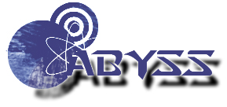

Table of Contents

Introduction 3
About Abyss Client 3
Regle of nomage / agreement 4
The Code 4
Organization of directories 4
Technical Architecture 5
Technical environment 5
Schema of the architecture 5
Techniques and Tools 6
Applicative Layers And Design Patterns 7
Production Test 8

Introduction

Welcome to the official documentation of Abyss Client. Abyss System thanks you for using this product and hope that your experience will be rewarding and constructive. This documentation explains in detail the architecture of the abyss project, what has been used for it and how.

About Abyss Client

Abyss Client is the all in one administrative application for industrial production server based on Windows 2003 Server R2 and Oracle Database 10g R1/R2.

If you have just acquired Abyss Client and want to use it, follow the Installation Documentation step by step to obtain an operational server with Active Directory and Oracle Database in function.

Abyss Client can be executed directly from your server, a computer of your domain or from a distant client (on the same local network of your server) who has administrative rights.

Regle of nomage / agreement

The Code

All the code has been written in English, included comments. However, for complicated comments, or in the fear of against sense, the French had been authorized the purpose of the operation being that everybody understands the code.
The names of classes always begin with a capital letter.
Constants are in capital letter only. If a constant consists of several words, these last ones are separated by the character '_'.
The attributes begin with a small letter. If an attribute consists of several words, the words coming to the suite begin with a capital letter.
The properties wear the same name as the attributes but begin with a capital letter.
We decided that the name of the methods should be intuitive and clear, even if it means defining rather long names of method (always within the limits of the reasonable).
The names of methods always begin with a small letter. In most of the cases, the methods are actions on the data of the class, and have to begin with a 'verb', followed by the data manipulated.
Components had been named as follows:
- A name of description (in English) beginning with a small letter.
- The character '_'.
- The trigram of the type of component.
The code in the classes is divided into region (via the commands #region and #end region put at the disposal by Visual Studio .Net).

Organization of directories

The working directory of the application contains a directory for every project of the solution .Net, organized as follows:
- Business : Contains business class
- DAO : Contains data access class
- Persistence : Contains abstractive layer class
- Utils : Contains generic class for the application
- Abyss Client : Contains windows form

Technical Architecture

Technical environment

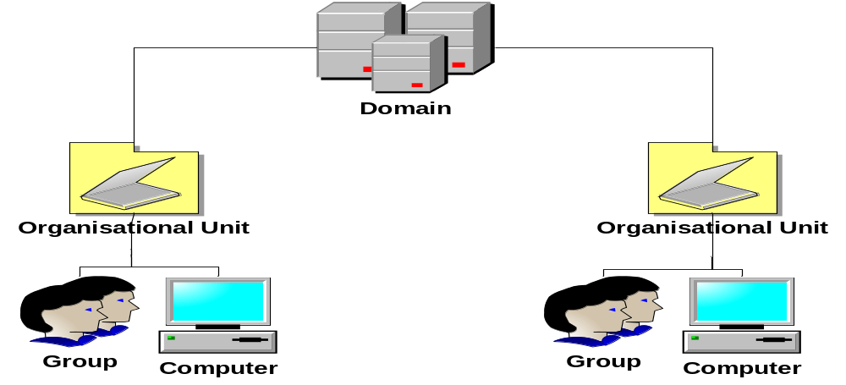

Schema of the architecture

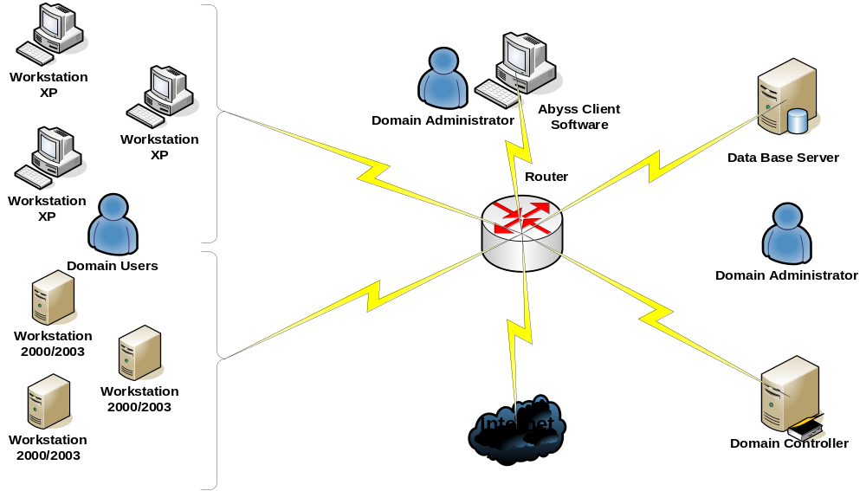

For the Abyss Project, we used a Windows 2003 Enterprise Edition and an Oracle Database 10g R2. In fact, we had need of an Active Directory domain where the authentication of the Oracle Users will be made through Active Directory.

This authentication had been possible by the integration of an Oracle Context in the Active Directory‘s schema and by the migration of an Oracle Net Service in this Oracle Context.

With these manipulations of the Active Directory‘s schema, we can create External Users, who are Oracle Users whose authentication is made by Active Directory. In fact, they don’t need a password and it’s the Operating System that will authenticate them when login in the domain.

With those possibilities that offer External Users, programmers can now create applications where for each user the connection to Oracle Data Base will be more secure and easier to set up.

Techniques and Tools

The application Abyss Client has been developed using Visual Studio 2005 in C# .NET on the framework 2.0. In this framework, we used the Directory Services namespaces that allowed us to manipulate LDAP object like Users, Groups and Computers. In fact, the use of this namespaces makes that our application is compatible with all LDAP Directory version 3.
The Data Base has been Oracle 10g R2. The connection to Oracle data base has been possible, by using OPD .NET 2.0 (Oracle Data Provider For .NET 2.0). For the needs of the Abyss Client, we had created one connection in Oracle that we named “ABYSS” that we grant DBA privileges like the system user.
The connection string for the application can be modified, by editing the Abyss Client.exe.conf file
<?xml version="1.0" encoding="utf-8" ?>
<configuration>
<connectionStrings>
<add name="OraConnect" providerName="Oracle.DataAccess.Client"
connectionString="Data Source=ORCL;User Id=ABYSS;Password=password"/>
</connectionStrings>
</configuration>

Applicative Layers And Design Patterns

The development of the abyss client has been directed to Design Pattern and evolution capacities. The application is cut in several layers:
- DAO Layer
- Business Layer
- View Layer
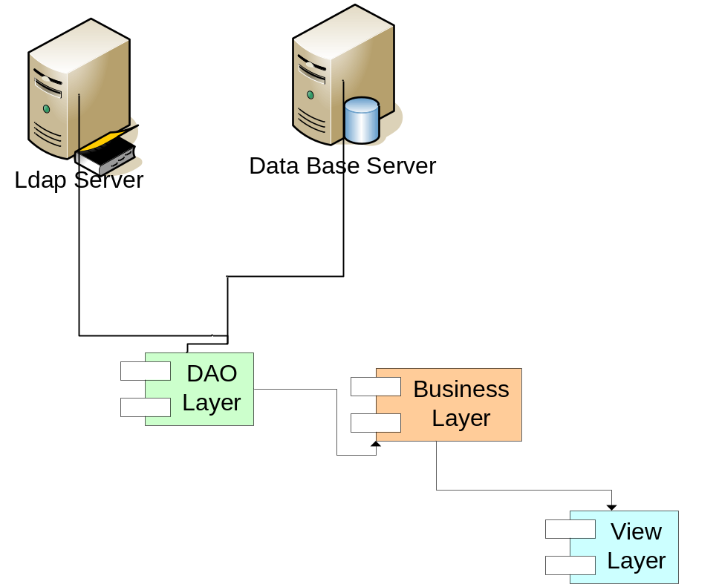
For the realization of our application, we decided that for a better development and maintainability of the application, we should use design patterns. In fact, we used patterns like the MVC pattern (Model View Controller), the DAO pattern (Data Access Object) and the Singleton pattern.
The use of the MVC pattern allowed us that the development of the Abyss Client could be made by separating the data (model) and the user interface (view), so if we must change the interface it will not affect the data handling.
The singleton pattern allowed us that we restrict instantiation of a class to one object. This is useful when exactly one object is needed to coordinate actions across the system.

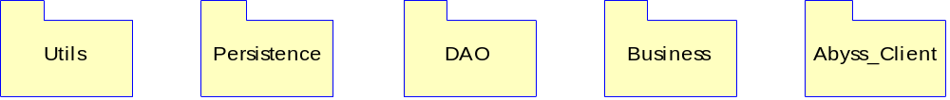

Production Test

Our entire test for the debugging of the application has been made with 2 Virtual Machines.
- One with in there is Oracle and the domain controller of our domain.
- One with XP Pro which member of this domain.

For a better deployment of our application, we built with Visual Studio 2005 an installer that can be deploying through GPO.
This installer contain the Abyss Client executable and all the documentations relative to the Abyss Project Solution.
